TCGA Methylations & Transcriptions Analyses and connections

In those analyses, the idea was to compare the impact of different mutations, from TCGA’s AML Patient data, that are involved in epigenetics modifications.

76 patients

Selection of patients based on their mutation profile (features from SNV TCGA pre analyses).
Mutant exclusif on A means patients with the mutation on A but not mutated in the other genes of the list.

- 6 IDHm exclusif
- 8 DNMT3am exclusif
- 6 WT1m exclusif
- 3 TET2m exclusif
- 5 FLT3-ITD exclusif
- 36 WT without mutations

Patient with DNA methylation, RNAseq and SNV data.
A patient with SNV data means that we can found his mutation profile.

Methylation analyses

Heatmap with WT and single mutations
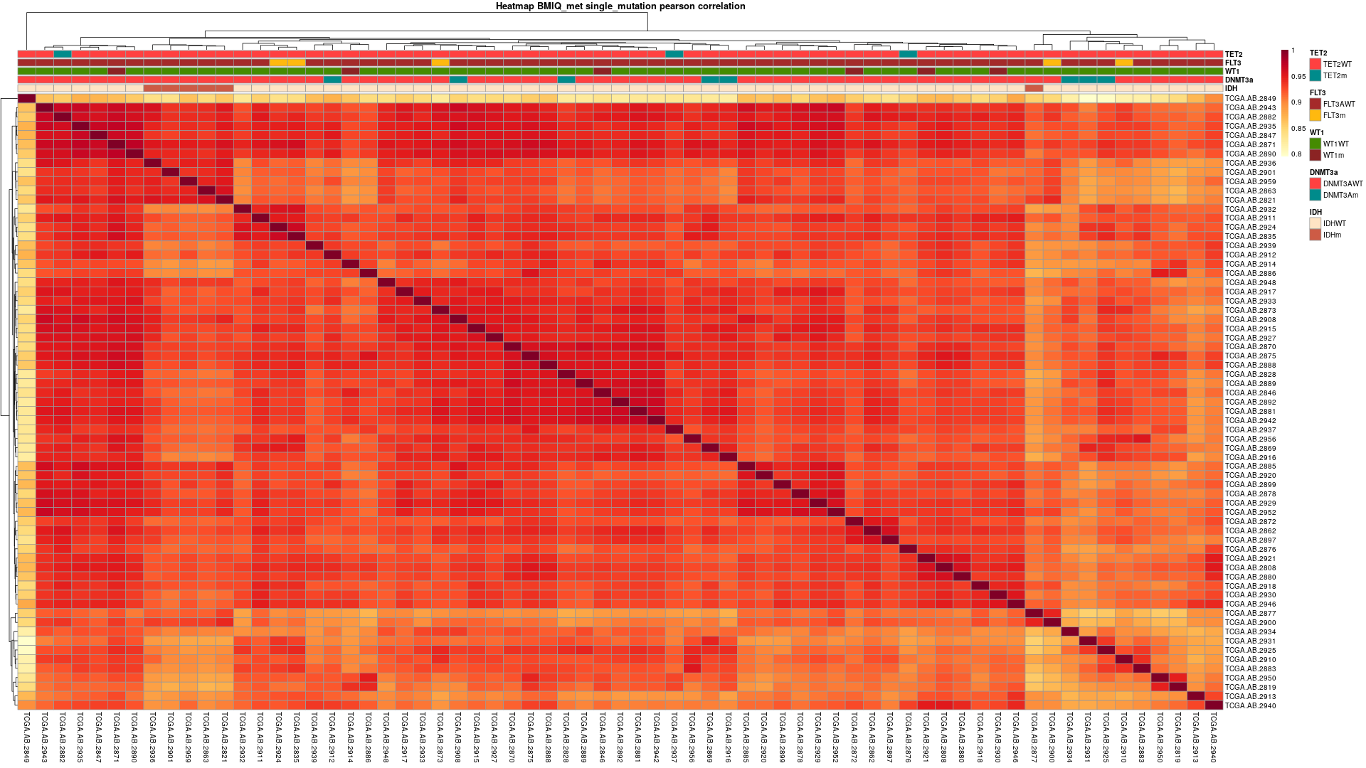
The heatmap shows a correlation between patient methylation profile. Red means that patients are close together (that’s why the diagonal is full of dark red). The upper legend shows the mutation profile for each patient. For example, the last column is WT for the 4 genes. The 6th on the right is FLT3 mutated.

Here I wanted to see if the profile of the different mutations can cluster each other. For IDH, except for one patient, mutated IDH patient are very close together. It is possible that some patient without IDH, WT1, TET2, FLT3 or DNMT3A mutations have other mutations that impact the methylome.

Heatmap without WT and single mutations
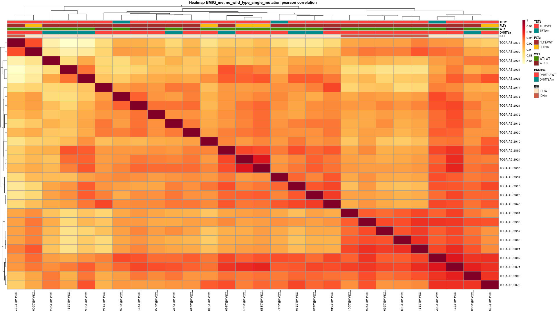

Here is the heatmap without those “WT”.

PCA of Methylation
To determine if there is a global shift in methylation between mutated and WT, I made a PCA (principal component analysis) and some volcanoplots.
The PCA is a computational reduction of dimension of a data set. Here, each patient has more than 300.000 variables (one per CpGs) that means 300.000 dimensions.

In this visualization, points are Patients cases. The pink ones are WT, the blue are mutants.
The position of a point corresponds to a specific profile of methylation and points close to it have a methylation profile close. Circles are the representation of the mean and the variability of the patients.
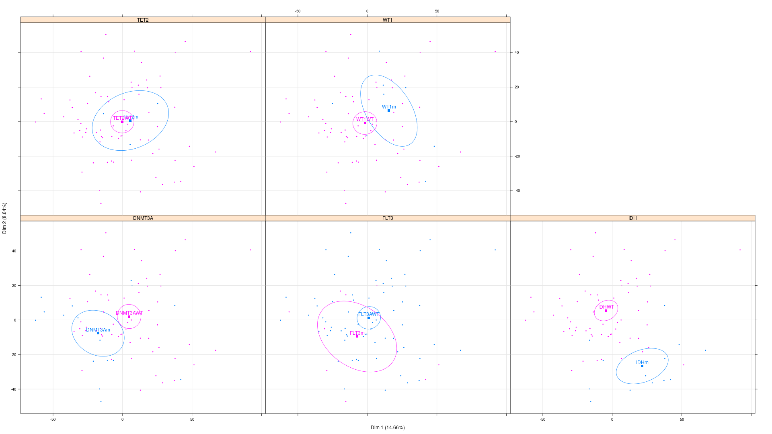
For DNMT3A, WT1 and IDH, red and blue circles are separated. That means their methylation profiles are different. It is strongly right for IDH where the variabilities are low and the distance between the two circles is high.

Volcano plot of methylation
In volcano plot of methylation, each point is a CpGs. X-axis corresponds to the log of the Fold Change of the Beta value between WT and mutant. Y-axis corresponds to -log of the Pvalue. Briefly, the points at the left are CpGs unmethylated in mutant end the ones at the right are upmethylated in mutant.

IDH
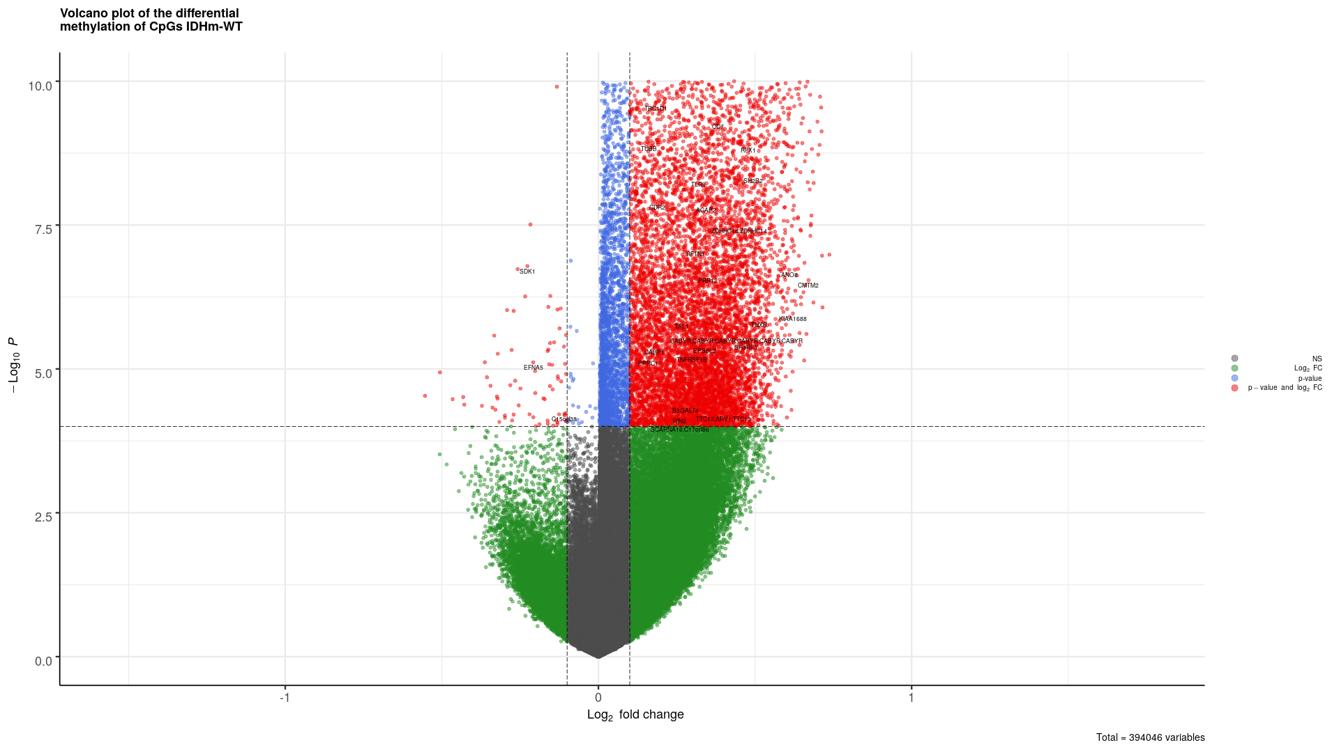
For IDH, there is a lot of points on the upper right corner. That means a significant upmethylation, a global shift of methylation in mutant.

DNMT3A
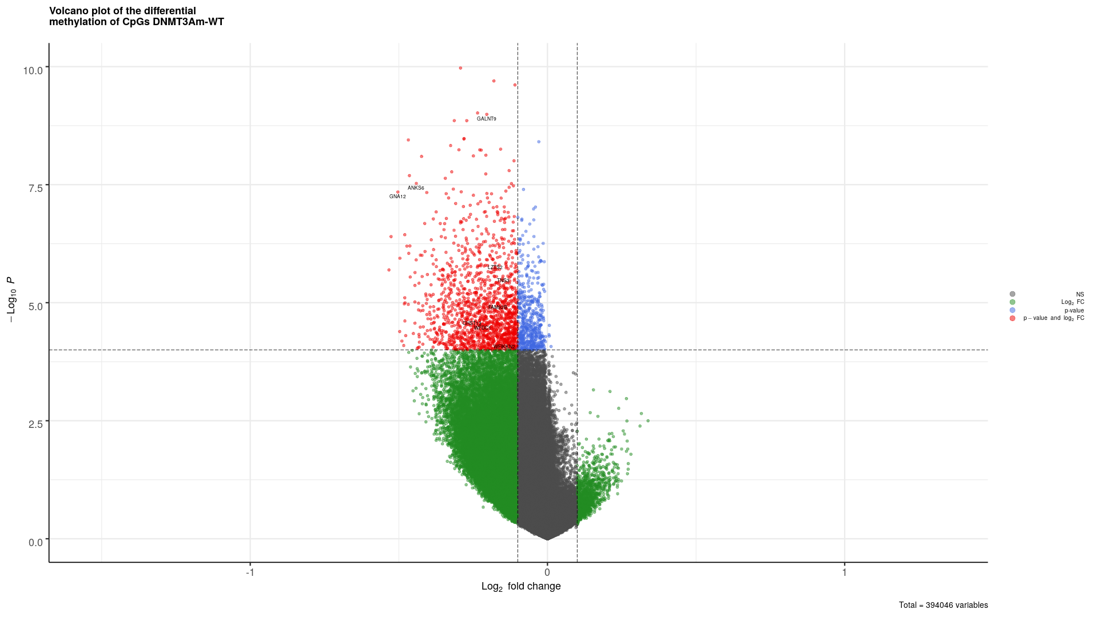

Here we can see the overall hypomethylation of DNMT3Am. As DNMT3A is involved in de-novo methylation, its mutation lowers its activity leading to the lack of methylation.

WT1

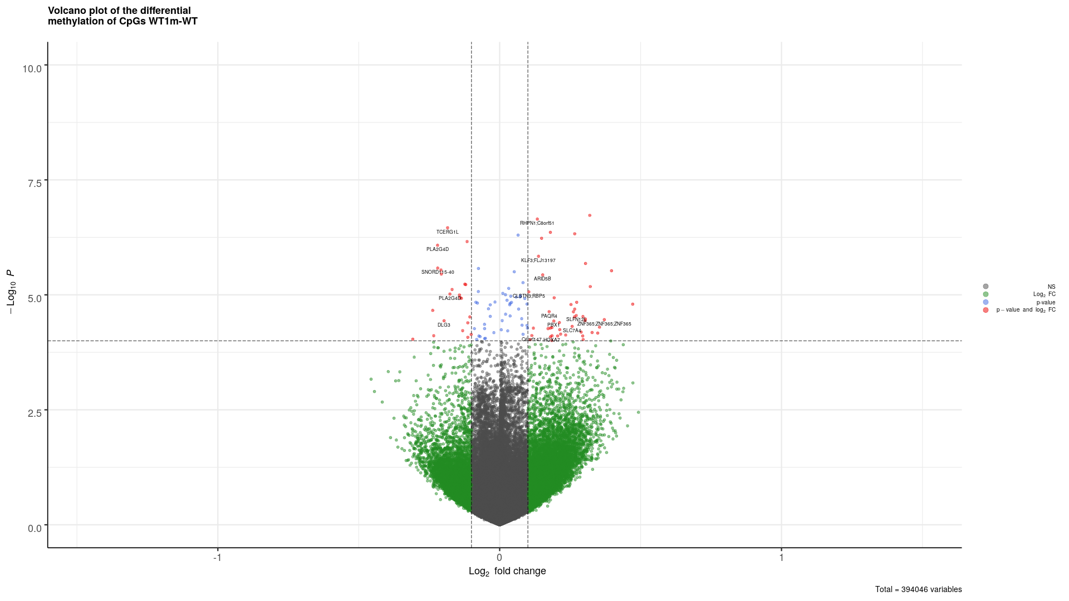
WT1 is a transcription factor that recruits TET2 to demethylate the DNA. Here we can barely see this by the slight hypermethylation of the CpGs.

Other comparisons
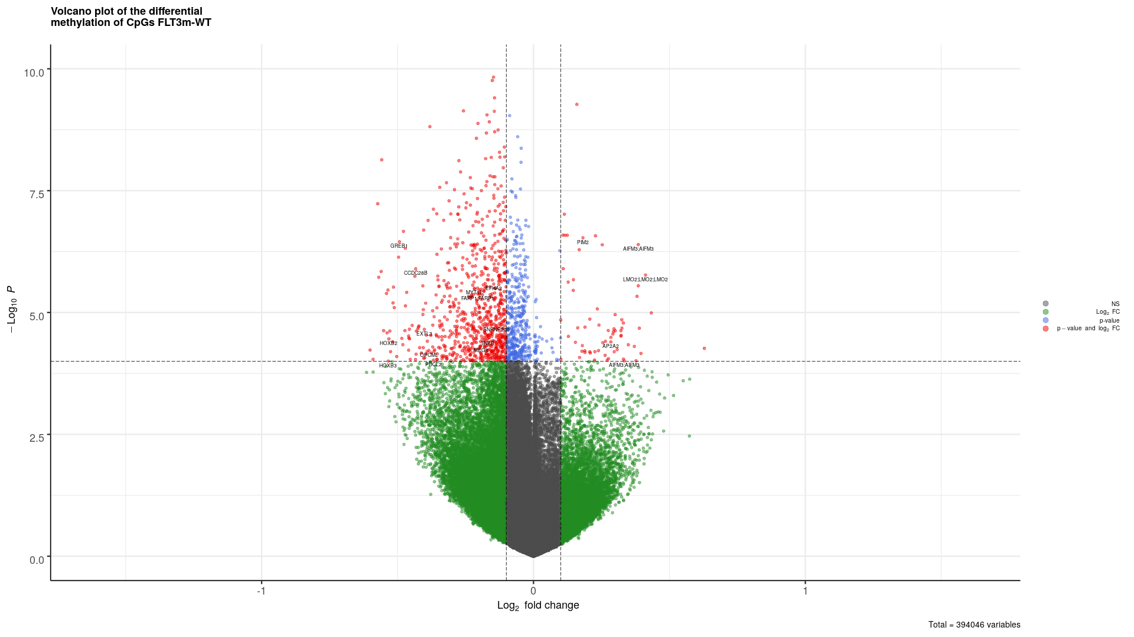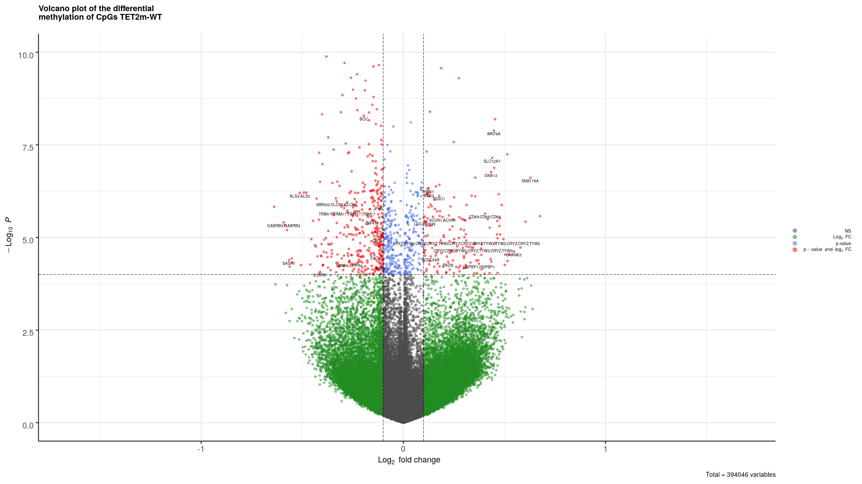
FLT3 TET2

FLT3 mutation seems to demethyl the DNA and TET2 doesn’t show strong results.

Transcription analyses

Heatmap with WT and single mutations
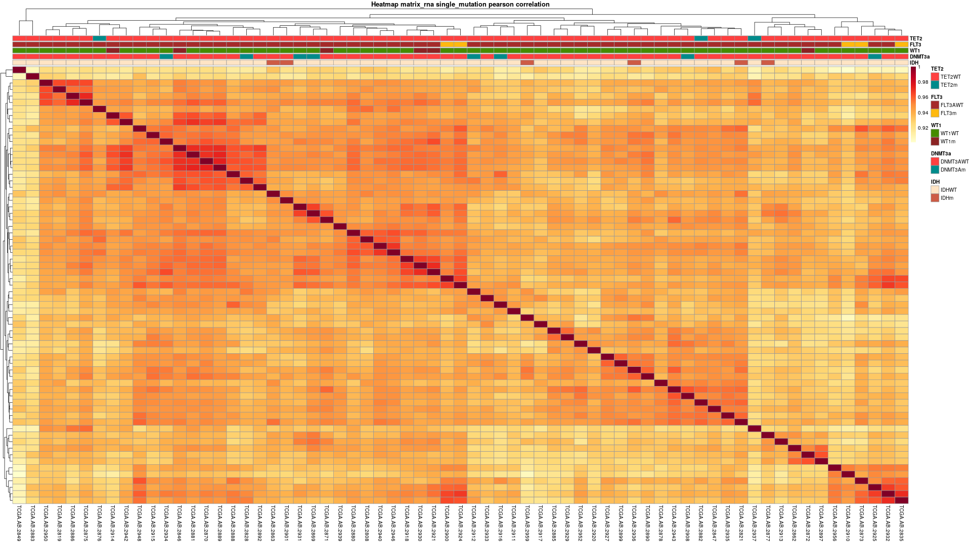

Heatmap without WT and single mutations
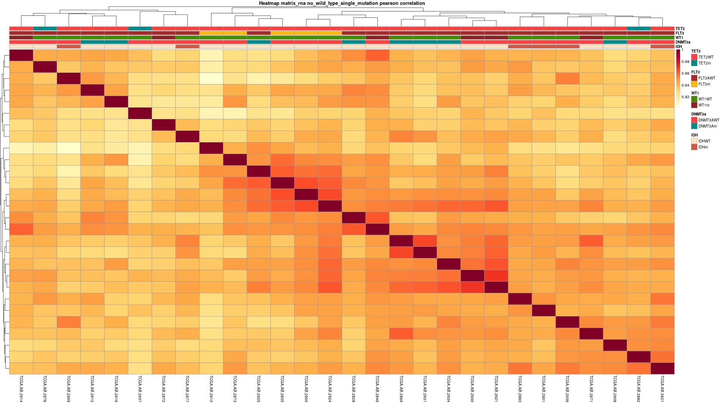

PCA of Transcripts
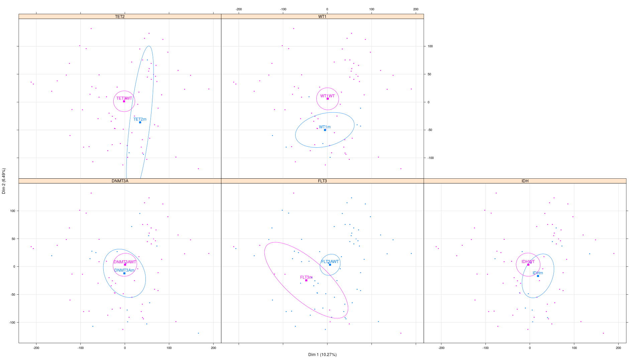

Gene Ontology analyses

IDH (links to the table UP & DOWN)
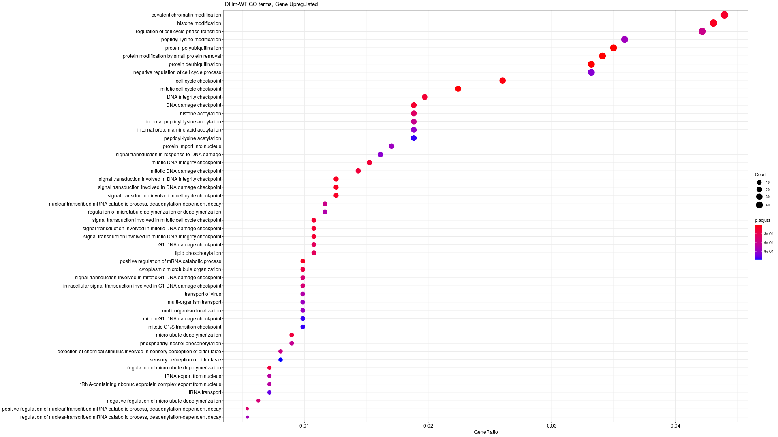
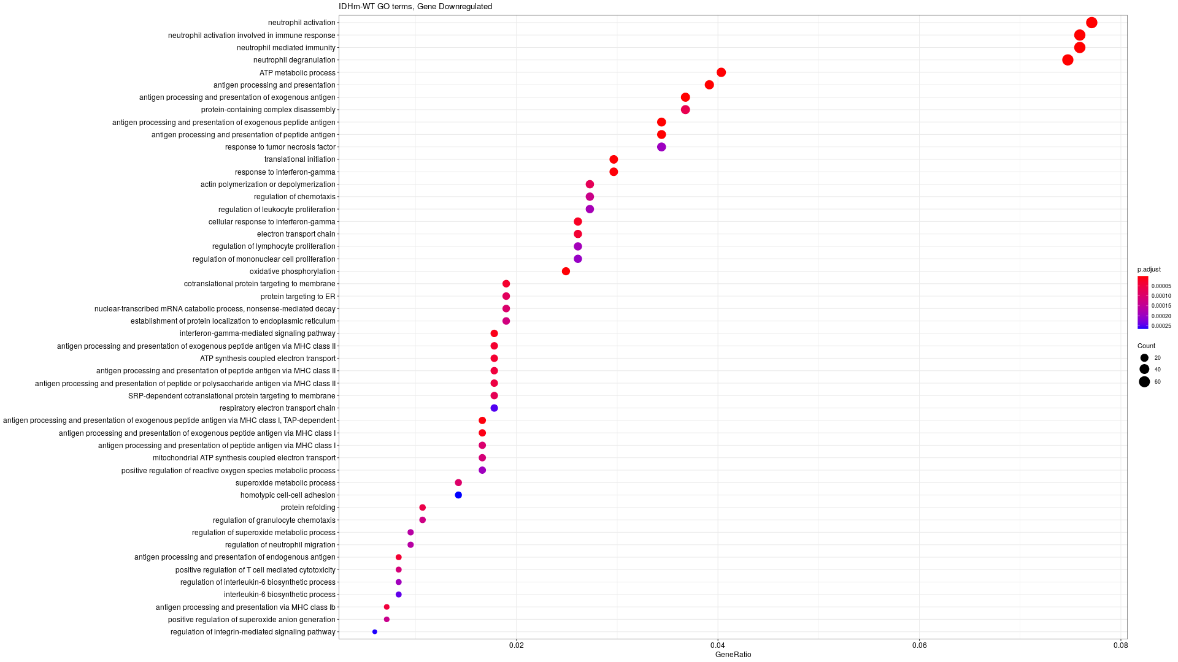
In IDH the gene ontology analysis of the ones that are up regulated in mutant we can see a lot of pathways involved in epigenetics like DNA damage, histone acetylation or chromatin modifications.
In gene down regulated, a lot of pathway are linked to mitochondrial metabolism. Electron transport chain, oxidative phosphorylation, mitochondrial ATP synthesis coupled electron transport etc.

Table of the Genes Differentially expressed

DNMT3a
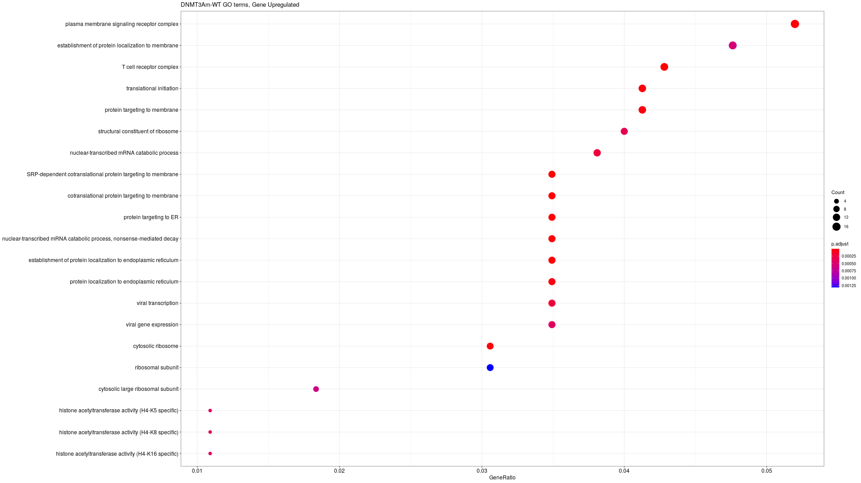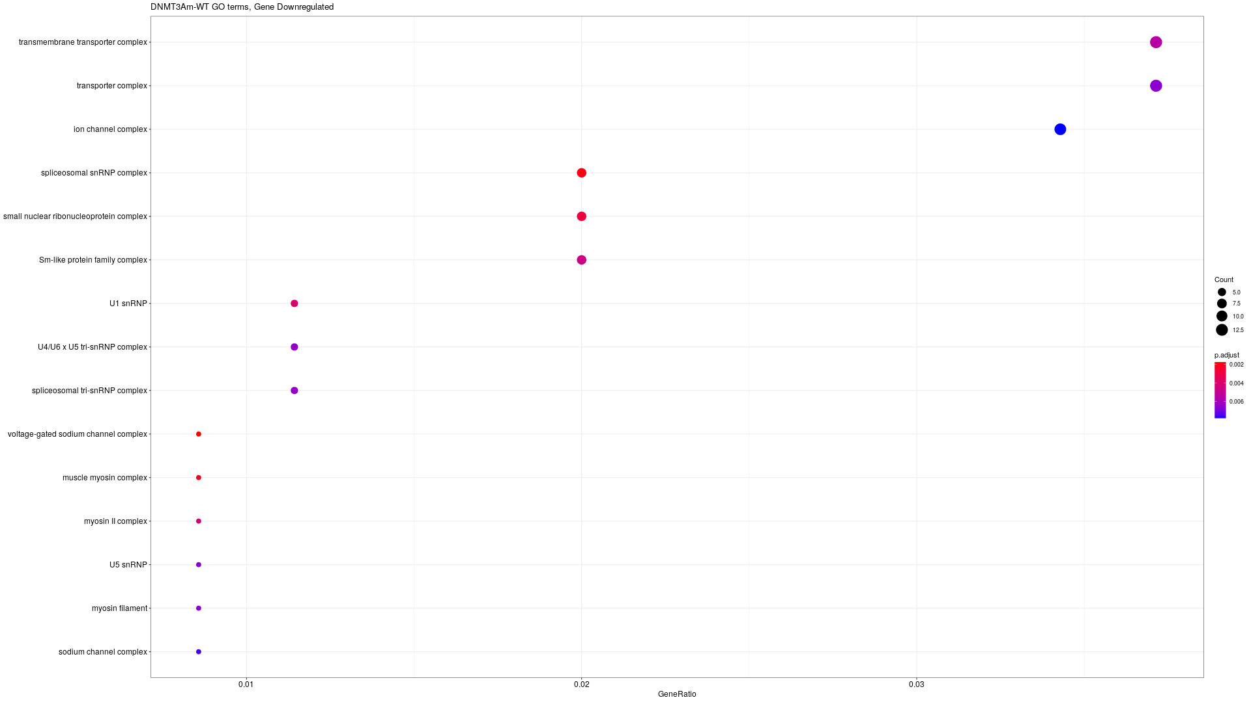

TET2m
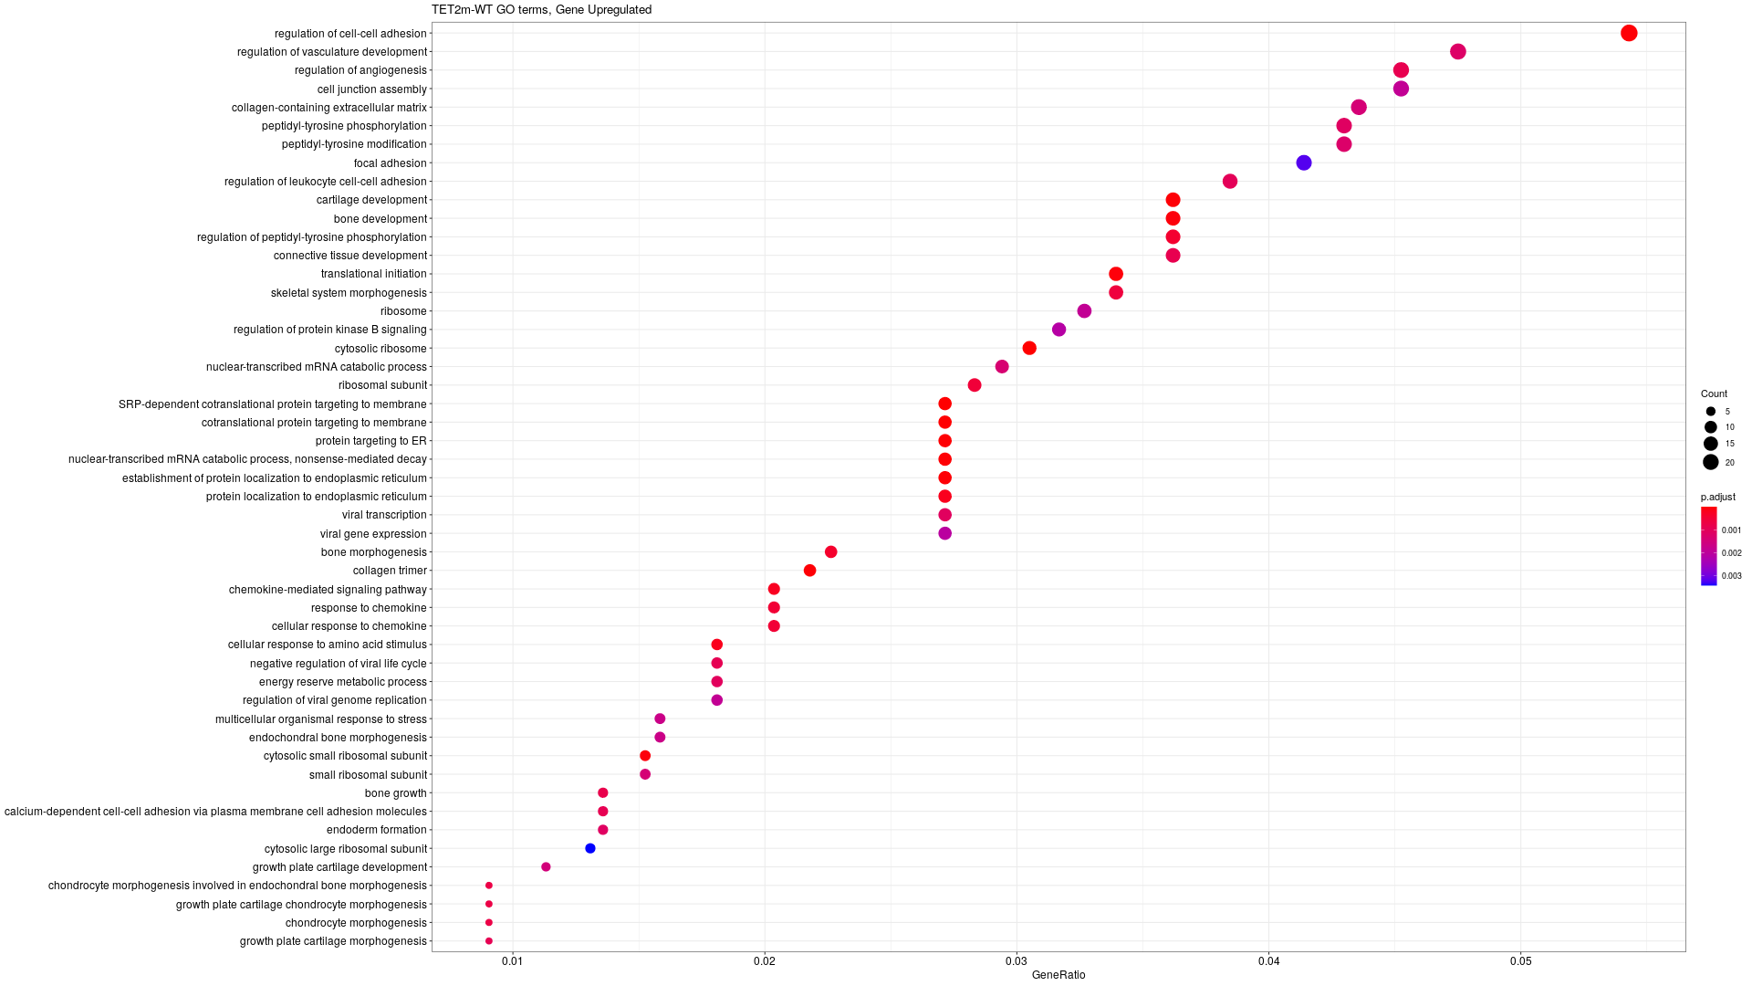
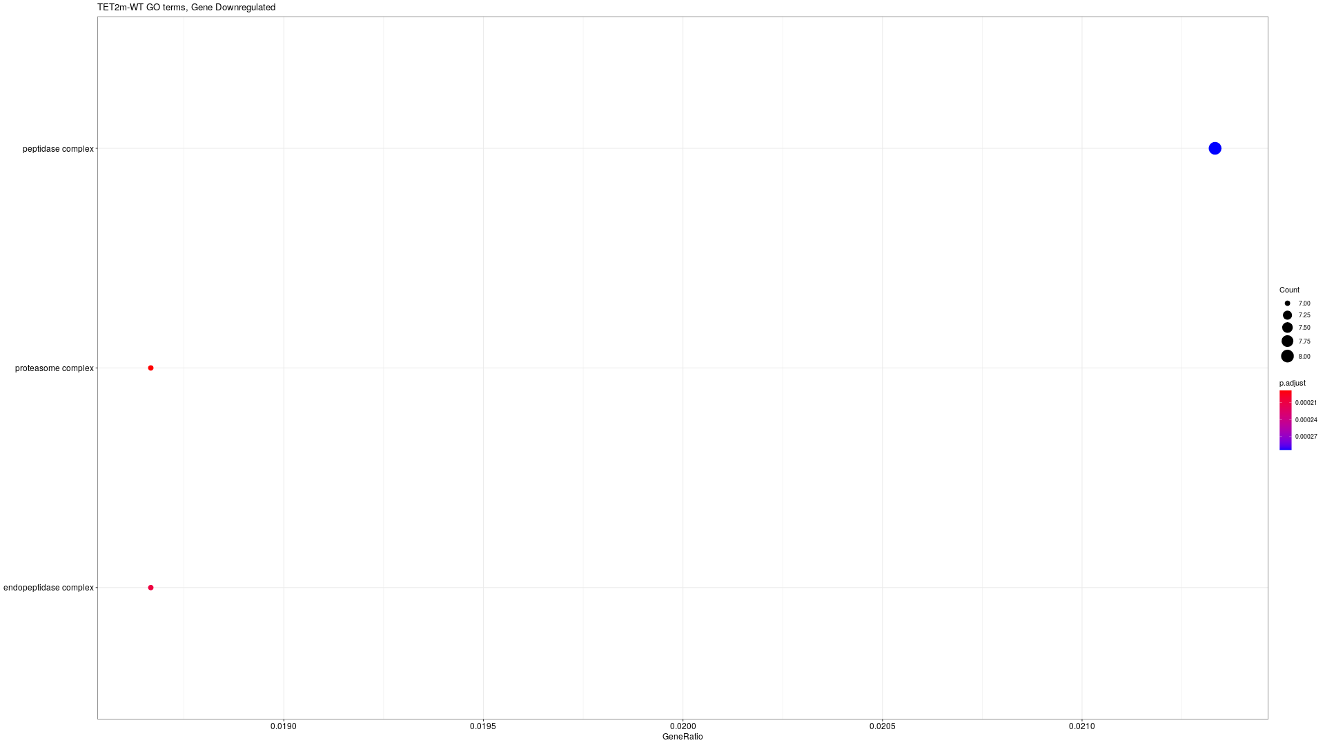

FLT3m
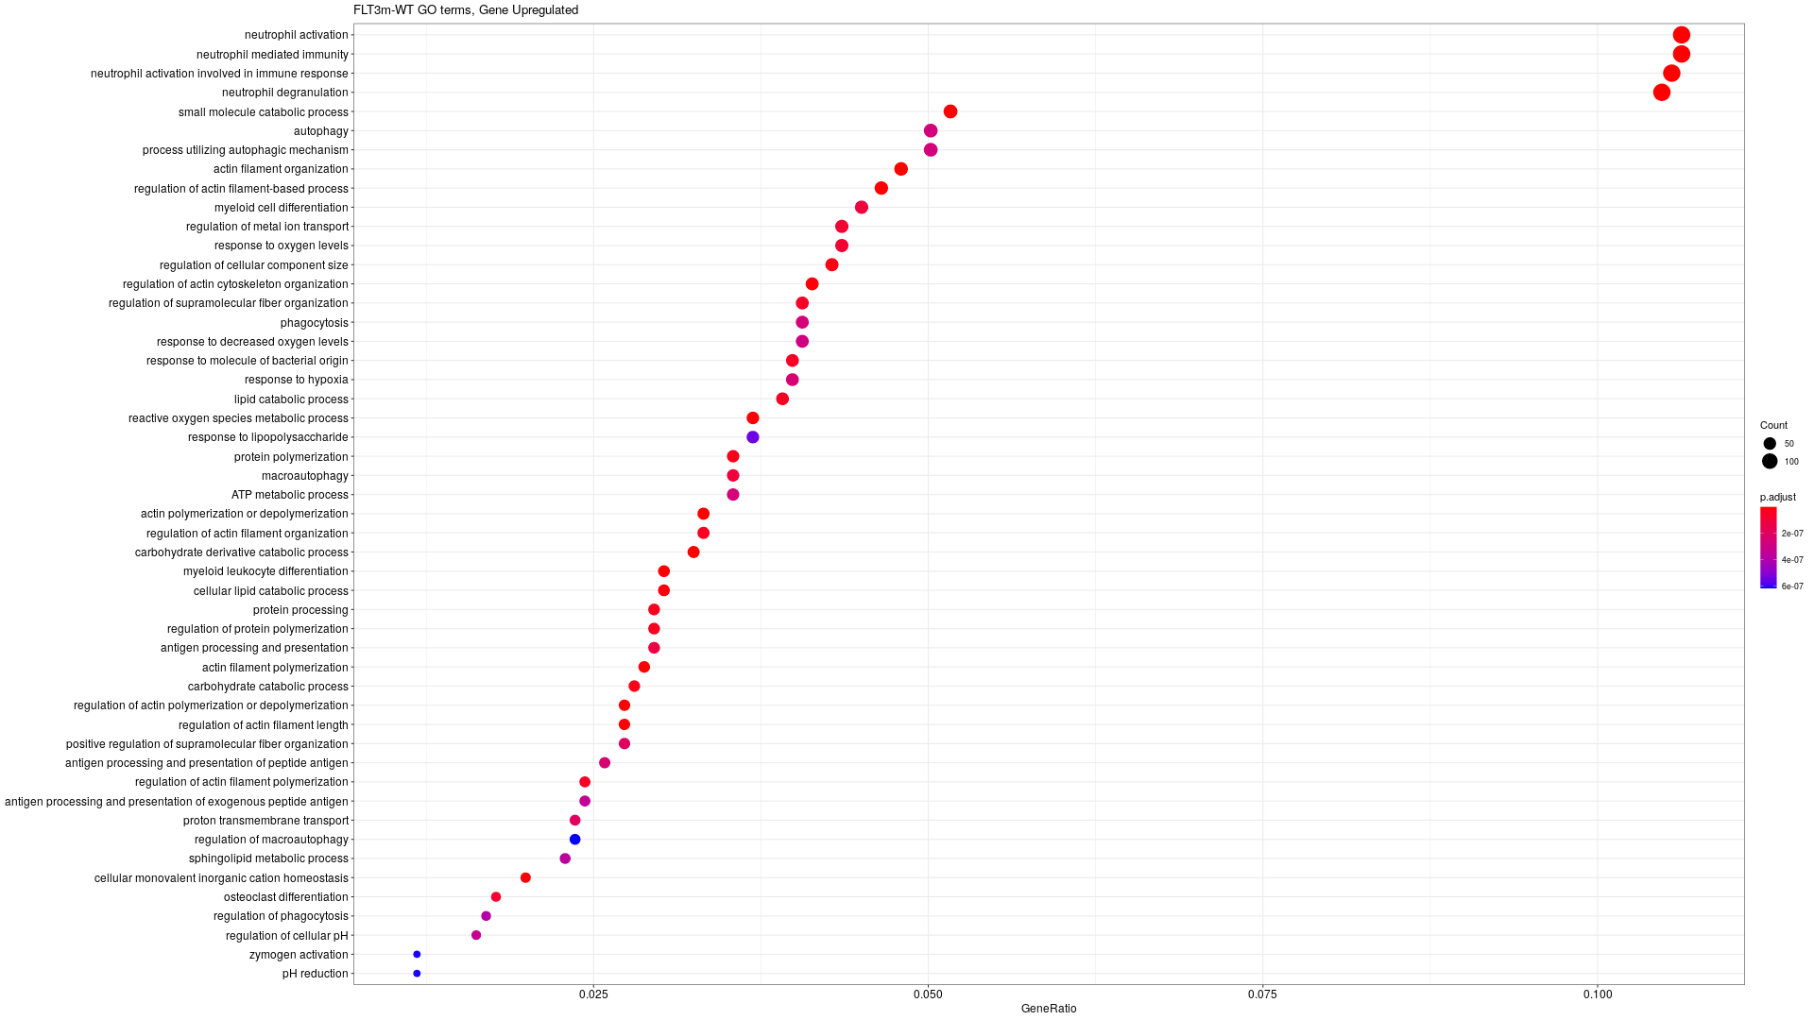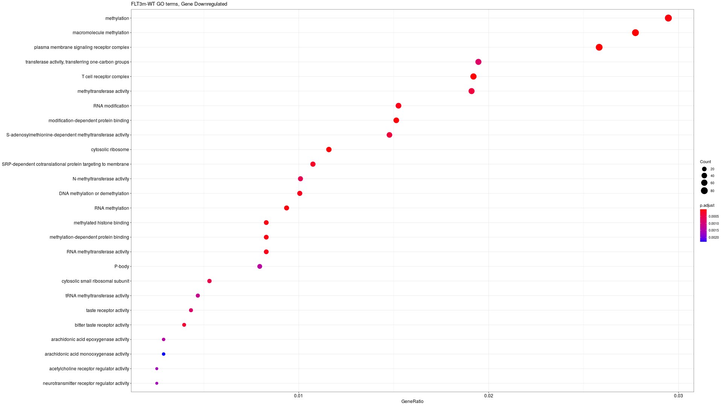

WT1m

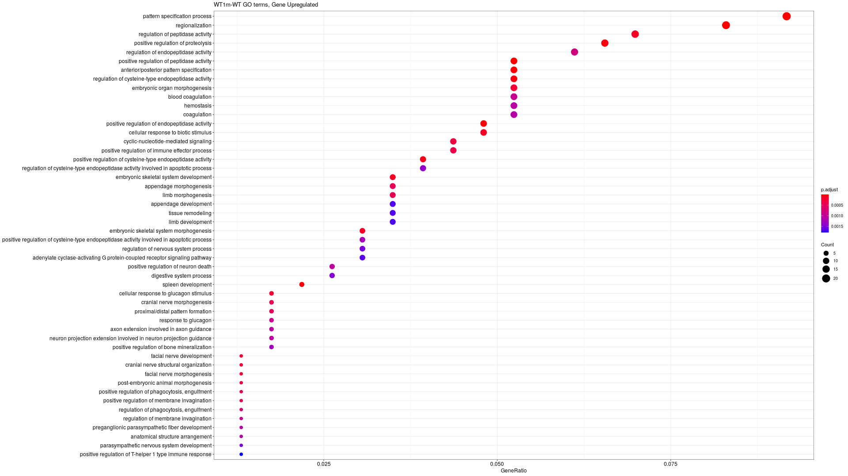

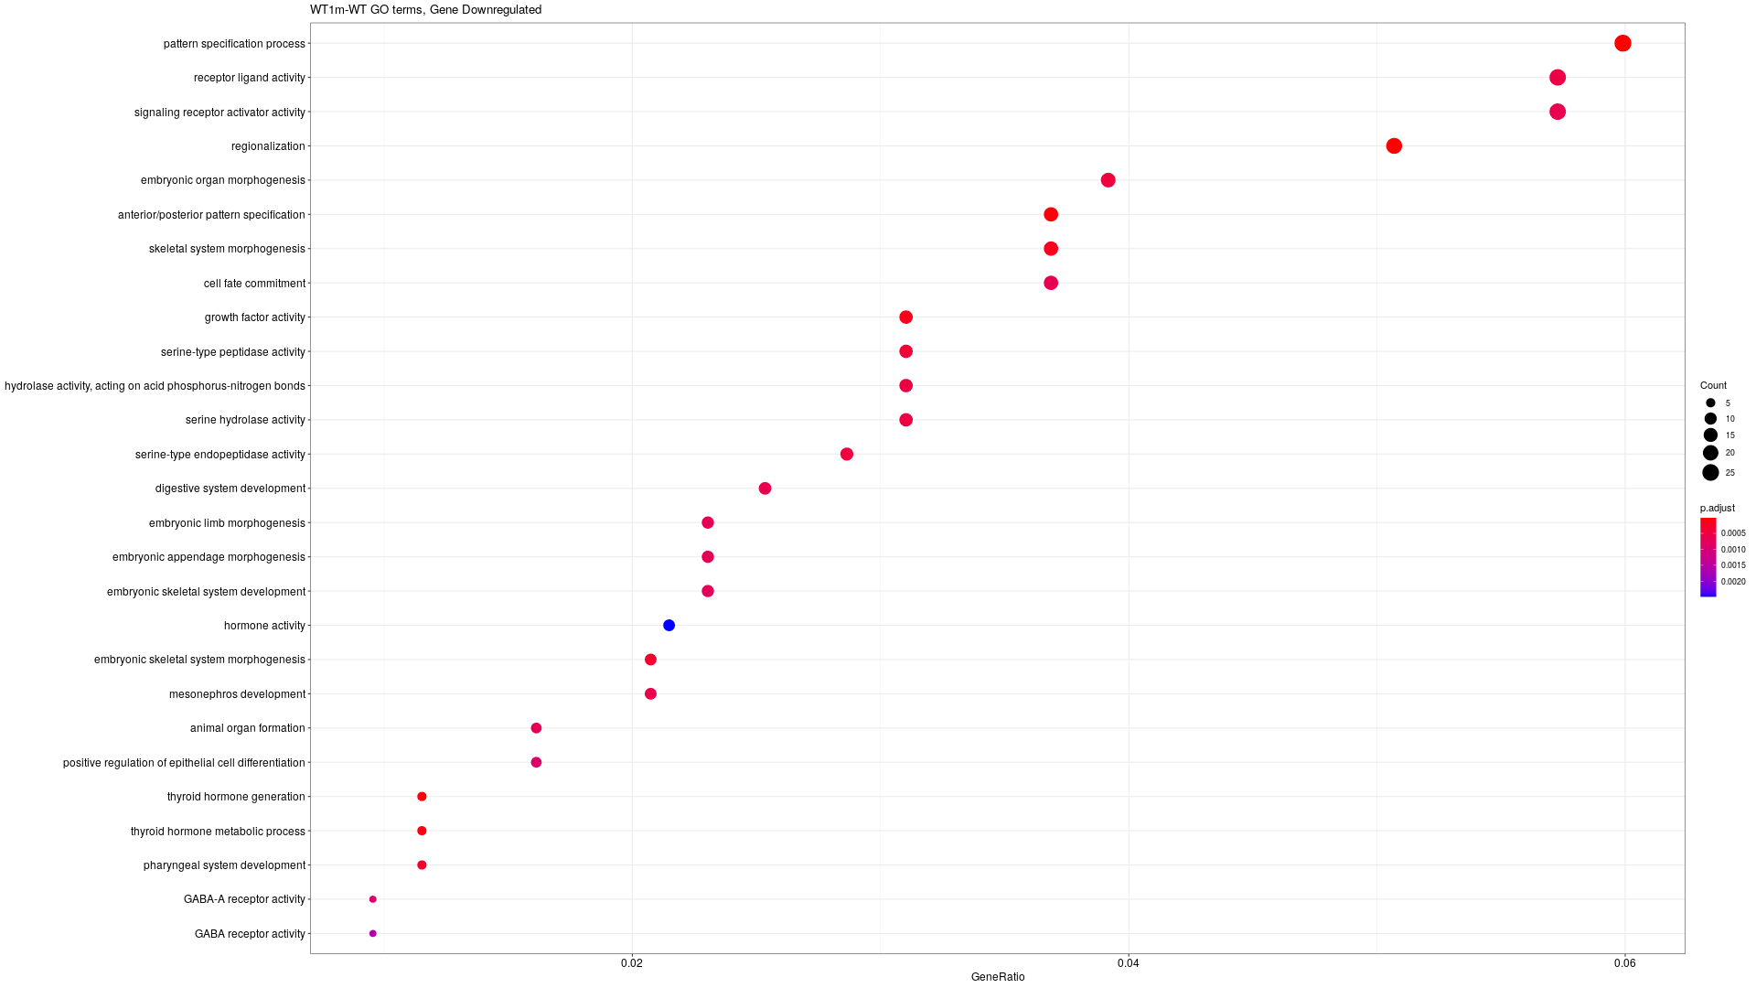

Some data (Link for the table)

 | IDH |  | DNMT3A |  | TET2 |  | FLT3 |  | WT1
CpGs DM |  | 9928 |  | 1187 |  | 2746 |  | 1463 |  | 314
Genes with promoter with CpGs DM |  | 7485 |  | 960 |  | 1818 |  | 855 |  | 296
Genes DE |  | 625 |  | 184 |  | 668 |  | 1995 |  | 246
Genes DE with promoter DM |  | 68 |  | 3 |  | 16 |  | 29 |  | 2
Genes UP with CpGs DOWN |  | 3 |  | 11 |  | 10 |  | 36 |  | 0
Genes DOWN with CpGs UP |  | 85 |  | 1 |  | 7 |  | 12 |  | 2
Genes with promoter in the neighbor of CpGs DM |  | 15929 |  | 4003 |  | 5946 |  | 4010 |  | 1497
Genes DE with promoter in the neighbor of CpGs DM |  | 224 |  | 30 |  | 77 |  | 181 |  | 9
Genes DOWN in the neighbor of CpGs UP |  | 63 |  | 0 |  | 5 |  | 23 |  | 7
Genes UP in the neighbor of CpGs DOWN |  | 3 |  | 8 |  | 7 |  | 20 |  | 0
Proportion Gene DE in neighbor of CpG (%) |  | 68,96 |  | 38,04347826 |  | 13,47305389 |  | 14,3358396 |  | 6,097560976

IDHm has a much more differences in methylations. (logFC > 0.3)

More than the ⅔ (68.96%) of the genes differentially expressed are connected to fragment differentially expressed. This proportion is lower in other comparisons.

List of the genes UP regulated with CpGs DOWN methylated in IDH
CLIC2, F2RL1, PCDHB15

List of the genes DOWN regulated with CpGs UP methylated in IDH
"ABI3", "ACY3", "ADGB", "AGTRAP", "AK8", "ANGPTL6", "C1QTNF4", "C20orf197", "C5AR2", "CACNA2D4", "CD1D", "CD300C", "CD300LB", "CD300LD", "CD93", "CD96", "CDA", "CEBPE", "CIDEB", "CLC", "CLEC11A", "CMTM2", "COL9A2", "CX3CR1", "CXCR2", "DAPL1", "DHRS3", "FBP1", "GALC", "GP9", "GTSF1", "HCG11", "HENMT1", "HLA-DMB", "HLA-DPA1", "HLA-DPB1", "IL12RB1", "IL27", "IL2RG", "KCNMB1", "KLHDC7B", "LDLRAD2", "LGALS3BP", "LILRA4", "LINC00649", "LRG1", "LST1", "LTK", "LY86", "LY86-AS1", "MACC1", "MAG", "MAP10", "MEFV", "MPZL2", "MS4A3", "NME3", "PDLIM1", "PHYHD1", "PTH2R", "PTX4", "QPCT", "RNU6-501P", "S100B", "S100P", "SEMA4A", "SEMA6B", "SERP2", "SIGLEC7", "SIGLEC9", "SLC37A2", "SLC9A3R2", "SLFN13", "SPATA12", "SULT2B1", "SUSD3", "TARM1", "TBC1D9", "TNF", "TNNI2", "TNNT3", "UTF1", "VSTM1", "ZNF185", "ZNF385A"

Genes potentially down regulated by enhancer up methylated in IDH
"ACOX2", "ADAMTS15", "ALPK3", "ARHGAP31", "ARTN", "C1orf127", "CACNA2D4", "CCDC149", "CD1B", "CD1D", "CD300LB", "CDK15", "CKM", "CLECL1", "CXCR2", "DYDC2", "ELOVL3", "FAM205A", "GGT1", "GLOD5", "GPBAR1", "GPR55", "GPRC5C", "HLA-DMB", "HLA-DPA1", "HLA-DPB1", "HLA-DQA1", "HLA-DRA", "HORMAD1", "IFI27L2", "KCNK6", "KYNU", "LAMB3", "LOXHD1", "LRRC25", "LRTM2", "MAP10", "MMEL1", "MNDA", "MYO7B", "NKAPL", "NPL", "OSCP1", "PHYHD1", "PRG2", "PTAFR", "RASSF4", "RGS10", "RNU4-27P", "RNU6-1042P", "ROGDI", "RPS6KL1", "SIGLEC12", "SIGLEC7", "SIGLEC9", "SIGLECL1", "SIPA1L2", "SLC2A6", "SMIM22", "ST14", "TMEM150B", "TNFSF15", "TYROBP"

Genes potentially up regulated by enhancer down methylated in IDH
"PCDHB15", "PCDHGB4", "PGAP1"

All the genes, their expression and the value of methylation of CpGs in their promoter

Deconvolution analysis (Link to table)

The analysis on deconvolution showed that some patient data have a lot of Macrophages M2 in their sample analysis. Other patient have a large majority of uncharacterized type of cell.

Network visualisation (IDH analysis)

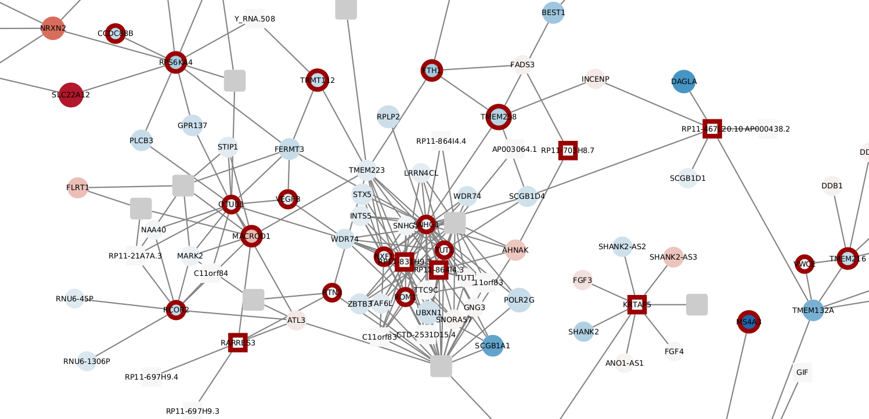

Blue nodes = Down regulated genes
Red nodes = Up regulated genes

Blue border = Down methylated fragment
Red border = Up regulated fragment

Circle are Promoters
Square are other ends

Edges are 3D contacts

Problem with visualisation:
- Some promoter are link to multiples genes but are named only with one of them (CEBPa for example is CTD-2540B15)

Target genes neighborhood

AKT3

IDH
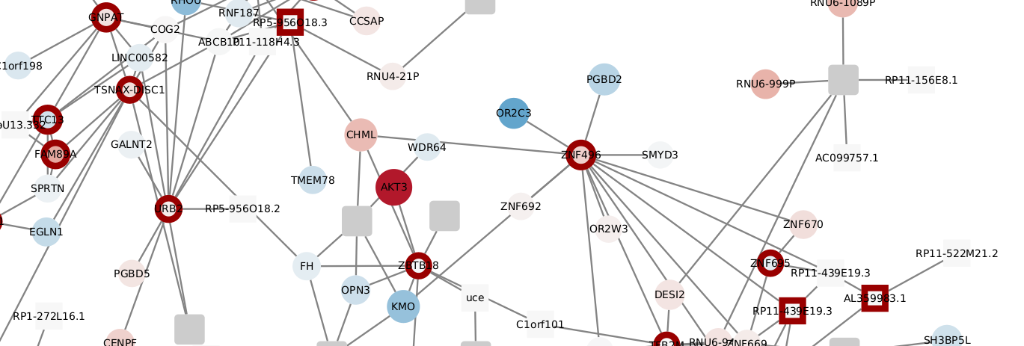
In IDHm, AKT3 is up regulated and its promoter is linked to a methylated promoter of the gene “ZBTB18”

CEBPa (called CTD-2540B15)

IDH

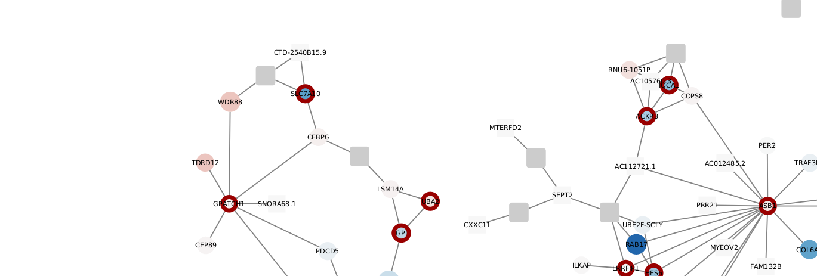
In IDHm, is slightly down regulated (logFC = -0.43117401 & Pvalue = 0.41629307) and its promoter is linked to a methylated promoter of SLC7A10.

DNMT3a
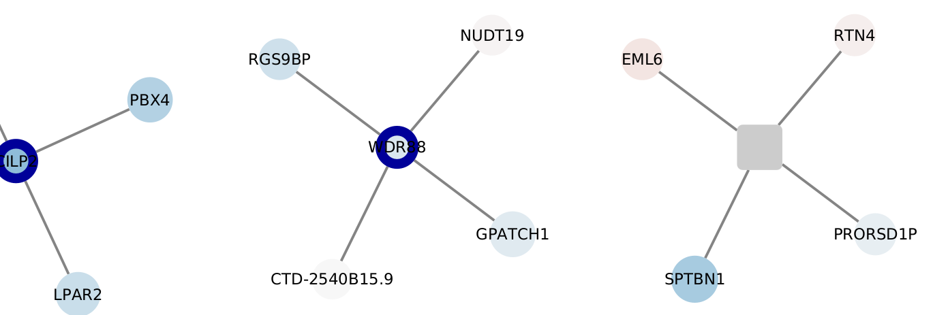
In DNMT3a, CEBPa’s expression in inchanged but it is linked to the unmethylated promoter of “WDR88”

PGC1a (called PPARG)

IDH
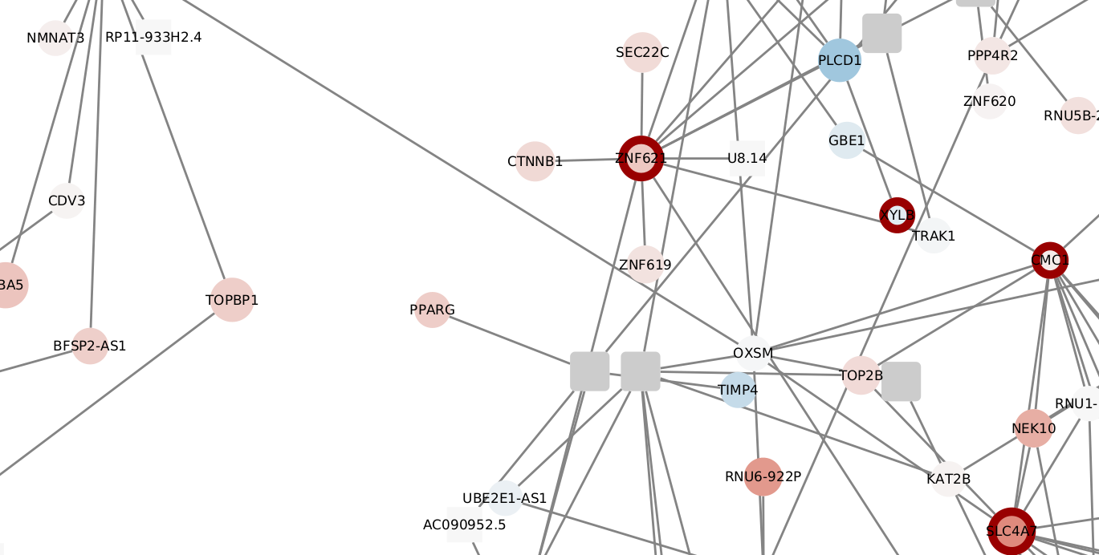
In IDHm, PGC1a is up regulated but is not linked to methylated fragment.

FLT3m

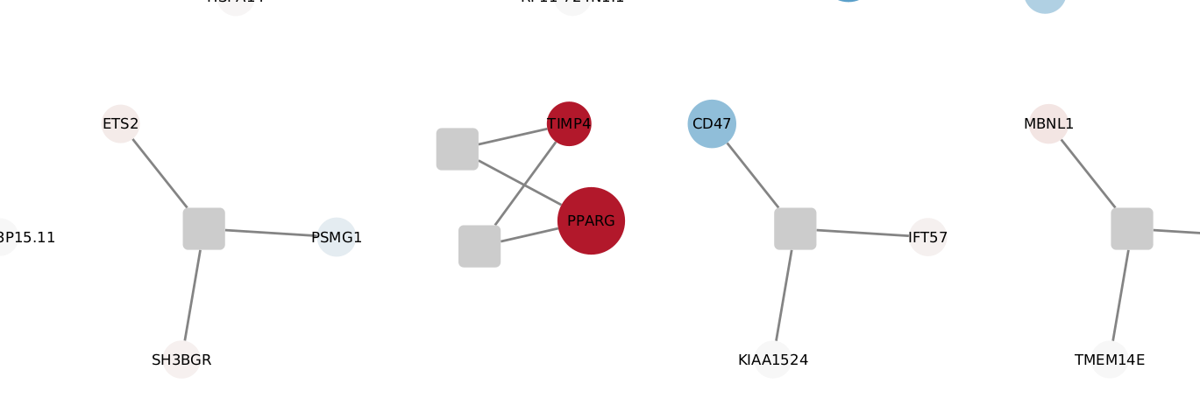
In FLT3m, PGC1a is upregulated and close to another promoter of gene up regulated: “TIM4”

SLC25A20

SLC25A20 is not found. Only SLC25A20P1 is referenced.

IDH

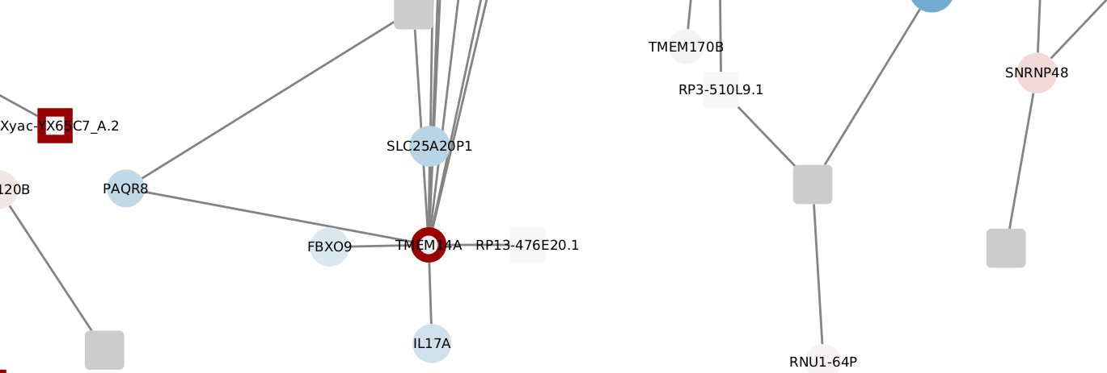
In IDHm, SLC25A20 is unchanged in its expression and SLC25A20P1 is linked to a methylated promoter”TMEMI4A”

PTEN

IDH

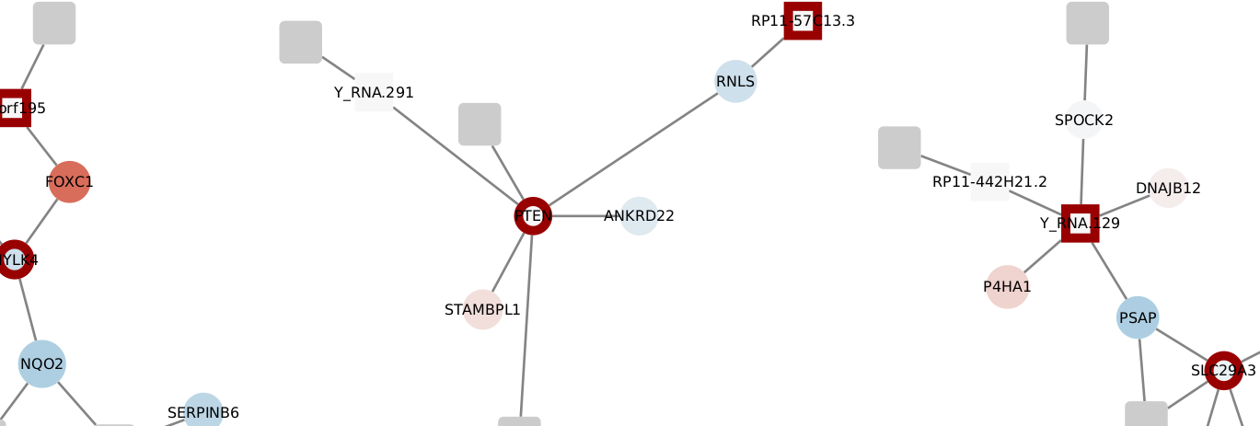
In IDH, the promoter of PTEN is methylated but its expression is unchanged.

FLT3m
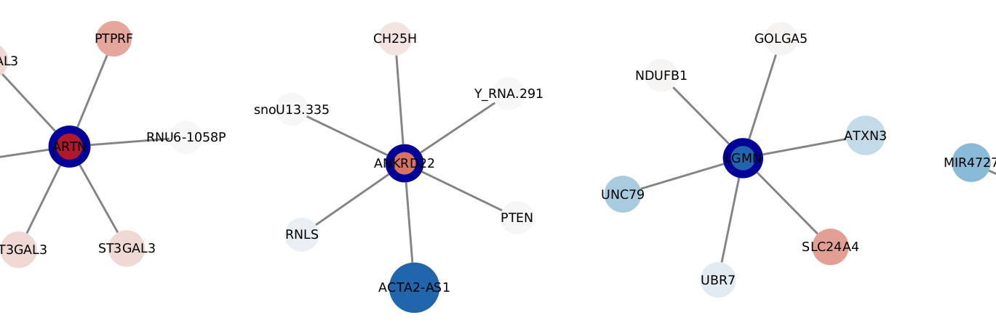
In FLT3m, the expression of PTEN is unchanged but its promoter is linked to the unmethylated promoter of “ANKRD22”

CPT1A

IDH
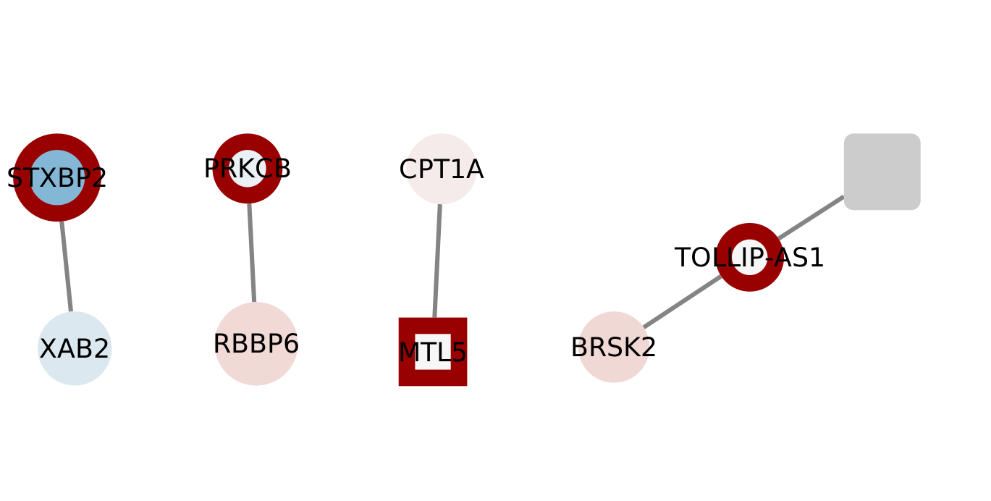
In IDHm, CPT1A is linked to a methylated fragment “MTL5” and is slightly down regulated.

